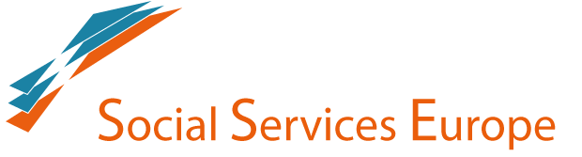

WORKSHOP
KNOW ABOUT THE AGENDA 2030 – WHAT’S IN IT FOR SOCIAL SERVICE EUROPE?
13 MARCH 2018
SOCIAL PLATFORM - Square de Meeûs 18, B
Since not all SEE members work on SDGs and some do work on them, but in different ways and from different perspectives the aim of the workshop is to develop a common knowledge on the 2030 Agenda among all the members as well as sharing practices on how SSE members are already using SDGs as leverage in their advocacy strategy.
Agenda:
9.00 – 9.20: Arrival and registration
9.20 – 9.30: Welcome and introduction to the workshop - Kélig Puyet, SOCIAL PLATFORM and Antonio Fantasia – CARITAS EUROPA
9.40 – 10.00: Overview on the 2030 Agenda and the SDGs, and an update on the current state of play - Barbara Caracciolo, SOLIDAR.
10.00 – 10.20: SDGs in Europe. SDGs as leverage for advocacy work on social policies at EU level - Peter Verhaeghe, CARITAS EUROPA.
10.20 – 10.40: SDGs as advocacy tool for social service providers towards a national government: the case of Austria - Cornelia Hackl, RED CROSS.
10.40 – 11.10: Multi-stakeholder platform of SDGs in EU, the Voluntary European Review 2019 and link with European Semester process. The work of Social Platform - Masha Smirnova, SOCIAL PLATFORM.
11.10 – 11.20: Coffee break

11.20 – 13.15: Open debate - moderator Luk Zelderloo, EASPD
a. How SSE could use SDGs for its advocacy work and promoting social services providers? What are the relevant EU policy processes for implementation of the SDGs in the EU?
b. Do SSE’s members already contribute to achieving the SDGs? Is there a direct link between services provided and SDGs and targets?
c. Based on the SEE members experiences, which methodology could be more efficient for SSE to work on SDGs?
d. Considering Social Platform work on SDGs, how to improve synergies?

13.15 – 13.30: Conclusions and possible steps forward - Jorge Nuño Mayer, CARITAS EUROPA

