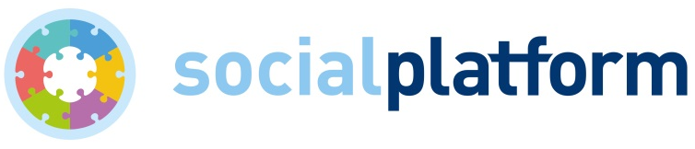

Brussels, 29 July 2019

CALL FOR CONSULTANT: Terms of Reference

To develop Social Platform’s analysis of the EU’s post-2020 Multiannual Financial Framework (MFF), and contribute to planning and implementing Social Platform’s advocacy related to MFF.

Location: Brussels

Duration: September 2019 to December 2019

Background:

Social Platform is the largest network of European rights- and value-based civil society organisations working in the social sector. As a membership-based organisation, it is safe to say that we would not be able to function without the strong support and participation of our family of members. Rather than focusing on our differences, Social Platform enables civil society organisations to nurture those elements that bring us together. Our mission is to advocate for policies that bring social progress to all in the European Union. We apply a human-rights approach to all of our work to fight for a socially just and cohesive Europe that promotes equality, diversity, solidarity, democracy and human dignity.

Europe has changed in the last five years. The current Multiannual Financial Framework (MFF) was negotiated in times of economic and social crisis, when many Europeans experienced the consequences of national austerity measures, such as unemployment and cuts in access to essential social services. Today, the future budget framework is being discussed in light of the United Kingdom leaving the EU, a crisis of European migration management, and growing populism and euroscepticism. As a response and reaction we should expect many Member States favouring a reduced EU budget, with higher proportions of money being prioritised for EU border management and defence, anti-terrorism and security, and less for priorities such as integration and social inclusion.

Another trend we are experiencing is the changing environment for civil society organisations in Europe. Funding cuts, support for projects rather than long-term core operations, and burdensome reporting and co-financing requirements are challenges on the funding side, while European NGOs also face high profile criticism and in some countries limitations of CSO-enabling environments, including regulatory threats to freedom of speech and association.

Available resources:

- Work done by Social Platform on MFF (positions and statements sent to decision-makers)
- The Social Platform Secretariat, to ensure coherence with Social Platform positions and institutional as well as communication tools, contacts and strategic guidance.
- The Social Platform MFF Task Force of engaged members.
Objectives:
The Consultant will support Social Platform’s work on the Multi-Annual Financial Framework (MFF) and specific future financial programmes. He/She will contribute to planning and implementing Social Platform’s advocacy actions in fields related to MFF.
Actions:

1) Analysis of our position on MFF in comparison with the outcomes of the trialogue negotiations (by Mid-September 2019): the aim is to evaluate if the final MFF is in line with Social Platform’s recommendations;
2) Contribute to the development of Social Platform’s WP for 2020 and beyond on MFF, in cooperation with SP team (participate to the team meeting on this issue);
3) Organise two MFF task force meetings: the week of 23 September 2019 and in November 2019. The aim will be to gather input from members on our strategy and in particular for our WP 2020, and to identify what members will do on MFF in the future;
4) And organise a Roundtable on Social Pillar and MFF at the EP, the first week of October 2019. The objective will be to raise awareness on the Social Pillar among MEPs and to look at how the future MFF would help to implement the Social Pillar.

Key deliverables: the analysis of our position on MFF in comparison with the outcomes of the trialogue negotiations, the part of our WP 2020 on MFF, organisation of two MFF task force meetings, and of a Roundtable on Social Pillar and MFF at the EP.

Organisational setting: the consultant will work under the supervision of the Policy and Advocacy Coordinator at Social Platform.

Deadline to submit proposals - 26 August 2019

Interested candidates are invited to send their CV and a methodology including time/work/
fee expectations for the four actions listed above.
Please send your proposals to:
Nathalie Franck (Finance and Administration Officer)
nathalie.franck@socialplatform.org

