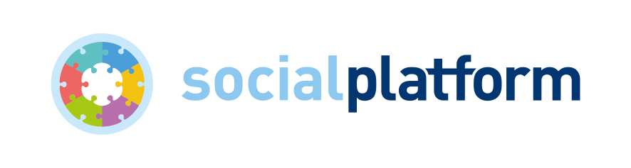

Membership application form

About your organisation

Name of organisation

Registered address

Telephone

Website

President

Secretary-General/ Director

Contact email address

Legal status & registration number

Type of membership being applied for | ☐ Full membership  ☐ Associate membership
Short description of the work of your organisation

Motivation for becoming member of Social Platform

Indicate the main reasons why your organisation would like to become a member of Social Platform and how your organisation can be of added value to the work of Social Platform.

Income

The membership fee for Social Platform members depends on the financial capacity of each organisation. Please indicate below the annual income of your organisation:

☐ Category 1 - annual income less than 50,000 EUR
☐ Category 2 - annual income between 50,000 and 200,000 EUR
☐ Category 3 - annual income higher than 200,000 EUR

Your members
Please send us a full list of your members or complete the table below, adding additional lines if necessary.

Country of establishment | Name of organisation | Responsible person | Address | Legal status
1.

2.

3.

4.

5.

6.

7.

8.

9.

10.

11.

12.

13.

Please include the following documents with your application:

- Statutes of your organisation (in English or French)
- Your organisation’s two most recent activity reports

Declaration

I declare that the information provided in this form is correct, and that I accept to respect Social Platform’s statutes.

Name and signature:

Date:

Please return this form to: Alva Finn, Secretary General of Social Platform (ailbhe.finn@socialplatform.org)

